
WACHEMO UNIVERSITY
DEPARTMENT OF INFORMATION SYSTEM
COURSE TITLE: C++
C++ GROUP PROGEACT
PROGEACT TITEL: DORMITORY MANAGEMENT SYSTEM
GROUP 7
GROUP MEAMBER NAME | ID NUMBER
- ABDLREZAK SULTAN | 1500573
- REIYAD SULTAN | 1501223
- REDI JEMAL | 1501214
- BONTU ALEMNEH | 1403188

SUBMITED DATE:
SUBMITED TO :
- Introduction
Technology is spreading its wing in almost every walks of human life activities. Now a day it is better if every activity is done using new technology in order to fulfill the need of human being, Organization, Enterprise etc. As today's world there are many organizations and each organizations needs to be preferable, computable and work on fastest way in order to satisfy users interest etc. i.e. they should have facilitate their activities in computerized way.
Many developing countries are in a good position to exploit the opportunity of technology revolution and advance human development. The information and communication technology provide new resource materials for expanding communication.
In fact the second half of 20th century has wittiness the global phenomena of an information explosion. The development in communication technology has made it possible for millions of people to have fast access to vast information presented in several forms. Today computer and other electronic device increasingly communicate and interact directly with other devices over a variety of network such as internet. The internet provides individuals and small business centers for the ability to communicate inexpensively.
Hence, developing the system using technology has a tremendous effect for organizations and offices; which is in our case the WCHAMO University computer based dormitory management system (WCUODMS). Currently, the system is manual based; due to this the students and proctors faces some problems Because of this, we are initiating to develop our project on dormitory system in order to minimize the problem by using computerized system.

1.1 Statement of the problem
Currently', WCU dormitory management system uses manual approach. To process the operation first the ministry of education sends all the information to the registrar bureau and gives to the student affairs (dormitory) and to the dinning office. After taking the list, they assigned students to each block and room. At that time they face different problems during operating their tasks Working by paper based i.e. manual system is not only affecting the management members, rather it also for student during viewing of their dormitory information. Some of those problems are:-
- Data duplication and Time consuming.
- Require more human power to assign the students
- Management inflexibility
1.2 Objective of the project
1.3.1General Objectives
The main objective of this project is to develop a new Dormitory Management System which solves the above mentioned problems with the existing system. This is achieved by designing a computer based system program that will change the actual manual processing into a computerized environment.
1.3.2Specific Objectives
In order to achieve the main objective, we have the following specific objectives:
- Developing user friendly interface.
- To keep the overall records associated with the dormitory and student information.
- To minimize the work load of the employees (proctors).
- To assign the dorm to the students without any fault.

1.3 Significance of the project
The new dormitory management and allocation system is highly reliable, easy, fast and consistent and will play a crucial role for reliable service for students, proctors, and for the management. The significance of the system includes:
- To minimize time and efforts needed to perform tasks
- To make tasks simple and efficient in every aspects
- To manage the students and building information
- Providing a well-organized and guaranteed record keeping system with minimum space and effort need.
- To enable the university to get acceptance in the outside community.
- Developing students' effective communication with the university.
1.4 Beneficiaries of the new system
The beneficiaries of the system are:
Students: the students can view their dormitory information easily and timely
Proctors and other administrative officials: they can access dormitory and related information easily.
University: the university gets better audience
1.5 Scope and limitations of the project
1.5.1 Scope of the project
Since WCU dormitory management performs its basic tasks manually the scope of this project is to develop and implement a new Dormitory Management system which will avoid the problems associated with the manual processing.
The proposed system includes:-
- Assign the dorm accordingly
- Enable students view their dormitory information easily and quickly
- Delete information, Generate report.
- Manage dormitory related information.

1.5.2 Limitations of the project.
- Failure of electric power and network connection
1.6. Feasibility Study of the new System
Feasibility study is essential to evaluate the cost and benefits of the new system. On the basis of the feasibility study decision is taken on whether to proceed or to cancel the project.
Need of the feasibility study:
- It determines the potential of the existing system. :
- It used to determine/finds out the problem of the existing system.
- To determine all goals of the new system.
- It finds all possible solutions of the problems of the existing system

1.6.1 Operational Feasibility
The system to be developed will provide accurate, active, secured service and decreases labor of workers and also it is not limited to particular groups or body.
1.6.2 Technical Feasibility
The system to be developed by using c++ programing language system development techniques without any problems and the group members have enough capability to develop the project. So the system will be technically feasible
1.6.3 Economic Feasibility
Dormitory management system is a computerize system which will reduce paper costs, proctors payment cost and time consuming during students allocation for each dorm. Generally the system that we will develop, DMS can bring a number of tangible and intangible benefits.
1.6.4 Political feasibility
The system to be developed is not conflict with any government directives, because it gives services for the people effectively and efficiently. So the government is profitable and the system will be politically feasible.

2. DESCRIPTION OF THE EXISTING SYSTEM
2.1 Introduction
This chapter describes the existing system, players in the existing system general work flow of WCU dormitory Management, report generated in the existing system, alternative solutions suggested existing system, finally the proposed system (functional and non-functional requirement).
2.2 Description of existing system
The current system of WCU dormitory management system is manual In order to arrange and allocate students to dorms, they have to follow the record as it is arranged by WCU Registrar office and allocate Students depending on department and the lists of the students' arrangement. After getting the list from the registrar office, the proctor allocates the students to each block and dorm. Since there are so many students, the allocation method causes problems like assigning female students to males' dorm and vice versa and also assigning students more than the capacity of the dorm. In addition to these problems during assignation.
2.3 Major functions of existing system
Even if the existing system is performs its activities manually (partial), it has different major functions.
- Arranging buildings for the allocation: here the total number of building is determined with its holding capacity
- Arranging students for allocation: here total number of students and their academic information such as department, sex, department, and age is received from student head office. Students are then arranged based on their sex, and their department for dormitory allocation.
- Dormitory allocation: based on the arrangement of students dorms are allocated for students along with associated dormitory resources, like lockers, tables, chairs, beds and the like.
- Generating allocation report: based the dormitory allocation the allocation report is prepared and posted for student when they arrive at the campus after annual break
- Managing and controlling dormitory materials: at the beginning and end of each year, dormitory materials are recorded and controlled whether they are functioning properly or not then appropriate measure is taken.
- Controlling student's discipline: In addition to the above functionalities student's discipline measures are controlled and recorded, whether they use the dormitory materials properly or not, and whether they act and perform things as per the dormitory rules and regulations.

2.4 Player of the existing system
An existing system compromises different players to carry out its job. Among those different actors (players), the most common are Proctor manager, this body provides the list of all students who fulfilled every requirement for allocation to proctors, Students, they will be placed in their dorm by proctors and assigned for the property they get from the proctor, Proctors, They involved strongly in the existing system. Proctors collect students list from registrar. After they get all these information's from this body they will place those students according to their sex, class year, department and faculty.
The major actors in the existing system are:
- Students
- Proctors and
- Proctor manager
2.5 Work flows in the existing system
To overcome or improve this manual operation the team comes up with a new Dormitory Management System entitled WCUDMS. This new system is that enables the users to access the services given by the system
The proposed system operates in the following manner. Normally the student in formation is added in to the system by student head office. Then the proctor assign student by inserting ID number . After doing this the system will generate the allocation report which contains dormitory information like student 'S name, id number
dorm name, and block name. Then student and other employers access the dormitory information and the system provide just sitting where ever they are.

2.6 Business Rules in the existing system
A business rule is effectively an operating principle or polices that must be fulfilled and obligated in order the system will function properly and effectively.it operating polices and principles of the organization.
BR1: Only one dorm is assigned for six or four students based on their block, and those students should live in the dorm which belongs to him/her.
BR2: Students should not change their dorm without the permission of the proctor with sufficient reason.
BR3: Students are allocated in such a way that male students are not allocated with female students.
BR4: Proctors should not assign one student in more than one dorm.
BR5: Proctors should not use student's personal information for other purposes
BR6: Buildings should be arranged before the allocation.
BR7: After the allocation reports should be prepared by proctors for students` i.e. for posting.

2.7 Paper document in the existing system
In the existing system they use different forms and reports to manipulate different records associated with the different activities. Among them Dormitory allocation form is one of the main paper document used in the existing system. The form is look like this:

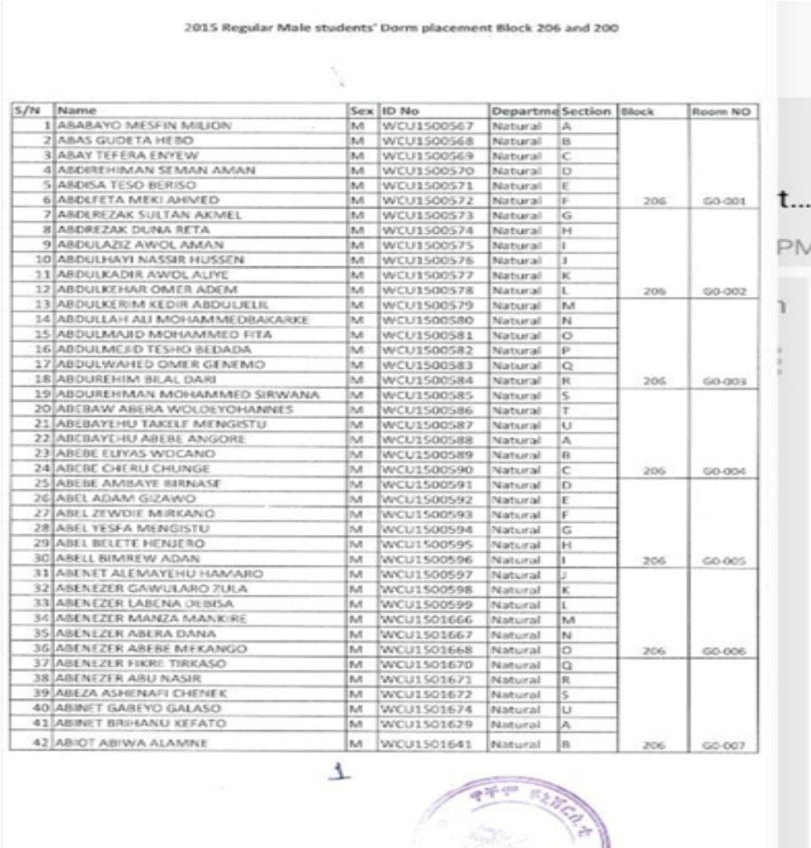

2.8 Problems in the existing system
The manual (partial) dormitory management system is disposed to various problems these problems can be seen from the following perspectives like performance, information, control, efficiency and services given by the existing system to the users
The performance of any system is required to show to meet the needs of users of that system. The current system's performance is weak.
This is due to the following reasons: first the acceptable quantity rate is relatively high i.e. the time required from initiation to completion of a particular task is relatively high. For example during arrangement of buildings for the allocation it may take a week or more due to its manual operation. Second is the acceptable response time for a particular task is large.
Information- the main input for the current system is student record and records of different dormitory materials which enable the system to rearrange students and buildings for the allocation. Based on this the system rearranges and allocates dorms for students at the beginning each academic year and generates the allocation report which may be viewed by the students as well as the management. The other data that is stored is record of materials associated with the dormitory. The system manipulates and manages all of these and other records manually on papers.
Controlling- since all the records associated with the manual system are recorded and stored manually the security that the system provide for the privacy of this records is not good. The system shouldn't provide sufficient protection for access and manipulation of the records associated with the system
Services- the main users of the current system are students and the management itself. The services given to users are not flexible, reliable and expandable i.e. the users must there in the campus to get the services given by the system. Those services given by the system are limited to a particular area.

2.9 Practices to be preserved from existing system
Even if the existing system is manual system as it has weakness it also has some strong side that we need to be preserved are:
- Provide the required infrastructure to the students.
- Protecting dormitory resources
- Posting dormitory information in each building
- Generation timely report.
- Assessing discipline cases.

2.10 Alternative solutions
In order to overcome the current system problems that exist in the functioning of WCUDMS, our project group members have put down alternative options. These are:
- Change manual system in to computerized system without affecting the structure of the existing system

2.11 Functional and Non-functional requirement
2.11.1 Functional Requirements
The major functionalities of the proposed system are:
- The system accept the record:
- Registration of valid students
- Registration of buildings and dorms
- Registration of proctors
- Assigning students on proper buildings and dorms based on, department
- View the room(search information)
- Generating reports of student`s information
- Generating reports of building's information
- Generating reports of proctor's information
- Updating information(student , room , Procter information)
- Delete information(student , room , Procter information)
- Reporting accident

2.11.2 Non-functional requirement
i. User Interface: This works as an interface between the user and the system by properly guiding the user how to use it and perform operations. Proctors can change the data in the WCUDMS based on their privilege, whereas, students can only view their dorm information and they can report an accident . Any sort of training is not required for using the system. It is important that the system is easy to learn. The input device is given to keyboard and the output is viewed on the screen.
ii. Quality Issue: Information in data file should be as much as possible correct and updated in each semester
iii. Security Issue: This system provides an access to an authorized user for each and every special function. Students can view their dorm information by using their identification card number(ID no).
iv. Error Handling: Our system handles the errors in a very efficient manner. It can tolerate to wrong inputs and prompts the users to correct the inputs.

3. Modeling the Function of the new system (use case modeling)
The main activities that are performed in this part will be:
- Identifying if there is any additional actors and use cases,
- Constructing a use case model,
3.1 Use case diagram
Use Case represents interaction between a user (human or machine) and the system
Use case components:
Actor: is a person, or external system that plays a role in one or more interaction with the system. And represented with:
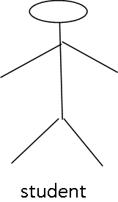

Use case: describes a sequence of actions that provides something of measurable value to an actor and is drawn as a horizontal ellipse.

System boundary: indicates the scope of the system project. Anything within the box represent functionalities in side in scope.

3.1.1 Actor identification
In the use cases an actor interact with the system to perform a piece of meaningful work that helps them to achieve a goal and has access to define their overall role in the system and the scope of their action. Depending on the above explanation actors in this system are the following:
- Student: The students view his/ her dormitory information online and submit comment
- Proctor: The proctor can assign student and generate report
- Proctor manager: search, generate repo
- Student head office:
3.1.2Use case identification
Each Use Case describes the functionality to be built in the proposed system, which car include another Use Case's functionality or extend another Use Case with its own behavior. The most important and basic use cases of this system are the following:-
- Allocate Student
- View dorm
- Submit comment
- View comment
- Register block (Allocate Proctor)
- Register room
- View Student Information
- Generate report

